**A FINAL PROJECT REPORT**

**ON**

**Development of NepEducation Website**

Submitted In Partial Fulfillment of The Requirements For

The Degree Of

**BACHELOR OF ENGINEERING IN SOFTWARE ENGINEERING**

**UNDER POKHARA UNIVERSITY**



**SUBMITTED BY:**

SUBASH SINGH DHAMI

(BESE, 221748, DAY)

**UNDER THE SUPERVISION OF:**

Er. SIMANTA KASAJU

Department of Software Engineering

Balkumari,



**NEPAL COLLEGE OF**

**INFORMATION TECHNOLOGY**

Lalitpur, Nepal

**Acknowledgments**

I would like to extend my sincere gratitude to all those who supported and contributed to the successful completion of the "**Development of NepEducation** Website" project.

First and foremost, I am deeply thankful to **Er. Simanta Kasaju**, my project supervisor, for their guidance, invaluable insights, and unwavering encouragement throughout the entire project. Their expertise and support were instrumental in shaping the project's direction.

I am indebted to the faculty and staff at NCIT for providing access to resources and facilities that were essential for the project's execution. The continuous support from my professors and peers significantly enriched my learning experience.

I extend my appreciation to the team of developers who dedicated their time and expertise to bring the **NepEducation** website to life. Their collaborative efforts and commitment to excellence have been truly commendable.

I would like to express my heartfelt thanks to my family and friends for their constant encouragement, understanding, and patience during the course of this project. Their unwavering support has been a driving force behind my efforts.

Finally, I am grateful to the users and potential learners who provided valuable feedback and insights during the development and testing phases. Their input played a pivotal role in refining the website's features and usability.

In conclusion, this project would not have been possible without the collective support and contributions of all those mentioned above. Thank you for being a part of this journey.

Subash Singh Dhami

Department of Software Engineering

NCIT

2080-05-13

**Executable Summery**

The "**Development of NepEducation Website**" project aimed to create an innovative and accessible online learning platform catering to the evolving needs of modern learners. Traditional education often faces challenges of limited access, lack of interactivity, and outdated curricula. In response, the NepEducation website was meticulously designed to bridge these gaps and provide a comprehensive solution.

The project focused on employing a user-centric approach, blending intuitive frontend design, robust backend architecture, and seamless database integration. Using a combination of HTML, CSS, JavaScript, PHP, and MySQL, the website offers an interactive learning experience that empowers users with practical skills in web development, digital marketing, and data science.

The website's key features, including a diverse course catalog, interactive learning modules, secure payment integration, and a community-driven environment, were developed with the intention of fostering engagement, inclusivity, and continuous growth. The project's success is evident in the positive user feedback received during the testing phase, emphasizing the impact of the platform on learners' educational journey.

Looking ahead, the project envisions an expansive future scope, including the addition of new courses, AI-driven learning enhancements, and further collaboration within the global learning community. The "**Development of NepEducation Website**" project not only addresses current educational challenges but also aspires to be a catalyst for reshaping the landscape of online education for years to come.

The project's execution underscores the commitment to accessible and interactive education, fostering a digital learning environment that empowers learners to excel in the dynamic world of technology.

Table of Contents

1. INTRODUCTION 4

2. STATEMENT OF THE PROBLEM 5

3. DEVELOPMENT METHODOLOGY 6

4. FEATURES AND FUNCTIONALITY 7

5. RESULT/ OUTPUTS 9

6. FUTURE SCOPE AND ENHANCEMENT 15

7. CONCLUSION 17

# Introduction

In a world defined by the rapid pulse of technological advancement, the realm of education stands at a crossroads of transformation. Welcome to the threshold of the "Development of NepEducation Website," a pioneering endeavor that transcends conventional learning paradigms.

As the digital tapestry of our lives grows ever more intricate, the demand for accessible, adaptable, and interactive education soars to unprecedented heights. The NepEducation website emerges not merely as a solution, but as a dynamic tapestry interwoven with the threads of innovation, empowerment, and limitless growth.

Picture a universe where knowledge surges beyond the boundaries of geography, where a student in one corner of the world can access the wisdom of instructors and peers across continents. In this era of limitless connectivity, the NepEducation website is more than a virtual platform; it's a conduit that unites passion with proficiency, aspiration with actualization.

From the elegant dance of code in web development to the intricate analysis of data in data science, and from the artistry of digital marketing to the symphony of collaborative learning, NepEducation encapsulates the essence of boundless learning. It stands as a testament to our commitment to fostering the intellectual evolution of tomorrow's leaders.

In a world grappling with outdated educational models, NepEducation is the embodiment of progress. Our journey is fueled by a singular pursuit: to democratize education, to empower minds hungry for insight, and to pave the path for innovation that reshapes industries and propels humanity forward.

Embrace this journey with us as we unravel a mosaic of knowledge in the digital realm. The NepEducation website is not merely an endeavor; it is a declaration of intent to redefine education, to nurture curiosity, and to nurture minds that stand at the vanguard of progress.

Welcome to the confluence of learning and technology. Welcome to the age of NepEducation.

# Statement of the Problem

In the middle of the ever-accelerating pace of technological advancement, traditional educational systems find themselves grappling with a fundamental disconnect from the needs of contemporary learners. The current landscape is marked by geographic limitations, a lack of interactivity, and curricula that struggle to keep pace with the dynamic demands of industries.

Geography should not be a barrier to education, yet learners often find their access to quality courses restricted by their physical location. Moreover, the rigidity of traditional educational methods often fails to cater to the interactive and practical nature of today's learning needs. Outdated curricula hinder learners from acquiring skills that align with rapidly evolving industries such as web development, digital marketing, and data science.

In this context, the "Development of NepEducation Website" project is driven by the imperative to bridge the gap between traditional education and the modern world's incessant hunger for knowledge and skill development. The mission is clear: to create an online learning platform that defies geographical limits, fosters interactivity, and equips learners with the contemporary skills needed to thrive in the digital era.

The development of the NepEducation website is not just about constructing a virtual platform; it's about crafting an innovative solution that tackles the core challenges that hinder holistic education. This problem statement serves as the cornerstone of our project, guiding our every effort to revolutionize education for the betterment of learners, industries, and society as a whole.

# Development Methodology

The "Development of NepEducation Website" project adhered to an agile development methodology, enabling iterative progress and adaptability. This methodology allowed us to respond dynamically to evolving requirements and incorporate feedback effectively. The development process was divided into several phases:

**a. Requirement Gathering:**

* Collaborated with stakeholders, including potential learners and educators, to identify key features and functionalities.
* Defined the scope of the project and created a detailed project plan.

**b. Design and Prototyping:**

* Created wireframes and mockups of the website's user interface (UI).
* Gathered feedback on design concepts to ensure user-friendliness and aesthetics.

**c. Frontend Development:**

* Employed HTML, CSS, and JavaScript to develop interactive and responsive user interfaces.
* Integrated modern frontend frameworks like React to enhance interactivity.

**d. Backend Development:**

* Utilized PHP to build a robust backend infrastructure.

**e. Database Integration:**

* Deployed MySQL to store user profiles, course details, and progress data.
* Ensured data security and efficient retrieval using database management techniques.

# Features and Functionality

The "Development of NepEducation Website" project has been meticulously designed to empower learners with an enriching and interactive educational journey. The key features and functionalities of the website have been crafted to address the challenges of traditional education and enhance the learning experience in the digital age.

1. **Comprehensive Course Catalog:**

**Feature:** Explore a diverse range of courses in web development, digital marketing, and data science.

**Functionality:** Users can easily browse and select courses aligned with their learning goals and interests.

2. **Interactive Learning Modules:**

**Feature:** Engage with video lectures, quizzes, assignments, and hands-on coding exercises.

**Functionality:** Learners actively participate in the learning process, reinforcing understanding through practical application.

3. **User-Friendly Interface:**

**Feature:** Navigate the platform effortlessly with an intuitive and visually appealing design.

**Functionality:** Users can access course materials, track progress, and interact with the platform seamlessly.

4. **Personalized User Profiles:**

Feature: Create and manage personal profiles to track course progress and engagement.

Functionality: Learners have a dedicated space to monitor their learning journey and connect with peers.

5. **Flexible Learning Schedule:**

**Feature:** Study at a self-defined pace, enabling learning to fit into busy schedules.

**Functionality:** Users can pause and resume courses without losing progress, accommodating real-life commitments.

6. **Secure Payment System:**

**Feature:** Safely enroll in paid courses through a secure and reliable payment gateway.

**Functionality:** Users can confidently make transactions without compromising financial information.

7. **Real-World Application Projects:**

**Feature:** Apply learned skills to practical projects that demonstrate expertise to potential employers.

**Functionality:** Users gain hands-on experience and build a portfolio showcasing their capabilities.

9. **Continuous Improvement through Feedback:**

**Feature**: Provide feedback to shape the platform's development and course offerings. **Functionality**: User input drives enhancements, creating an evolving and learner-centric environment.

By integrating these features and functionalities, the **NepEducation** website not only addresses the limitations of traditional education but also creates an environment that nurtures curiosity, facilitates collaboration, and equips learners with the skills needed to thrive in the digital landscape.

# Result/ Outputs

In this section, there is a form page where either you need to login or register the user. The page contains two switchable forms (login and register form) with a form open close button on the header section. The login form with automatically open in the delay of 1100ms or you can open the form by clicking the login button in the header.

**Login(seen by default):**

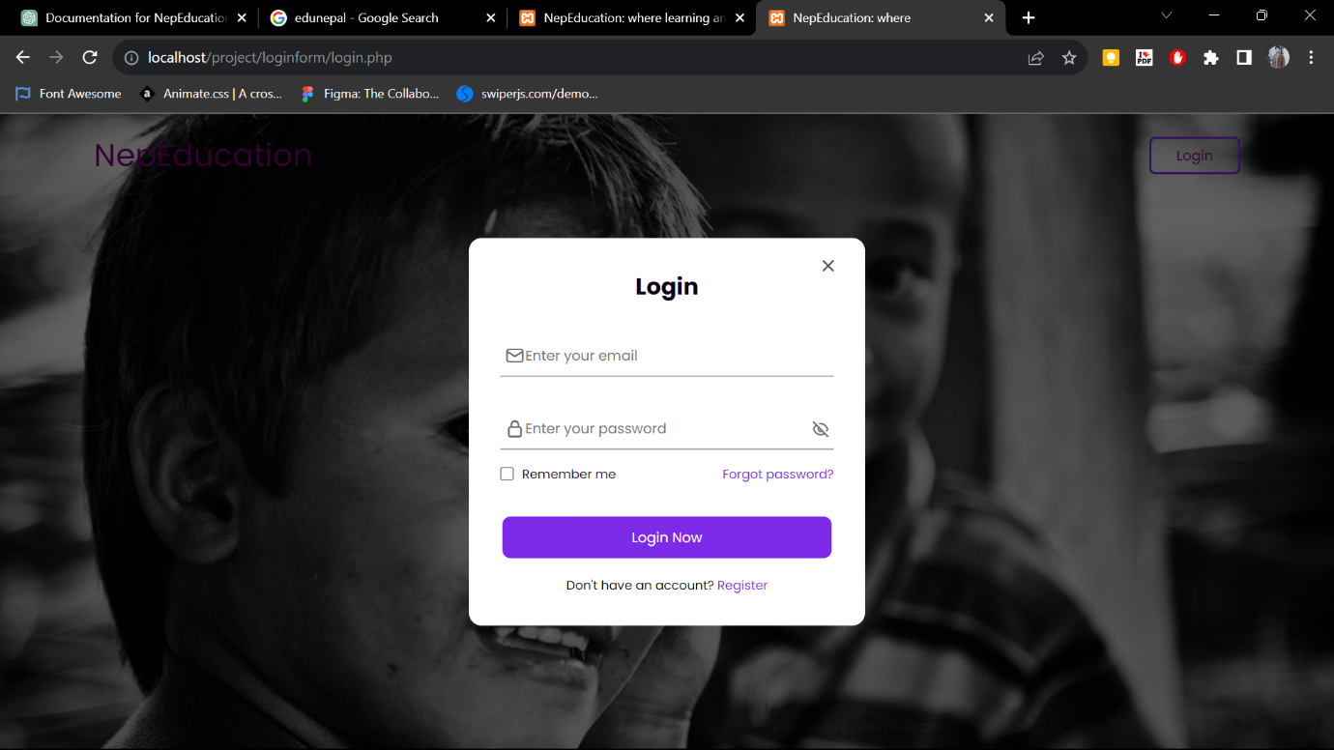

**Register page(navigated when clicked):**

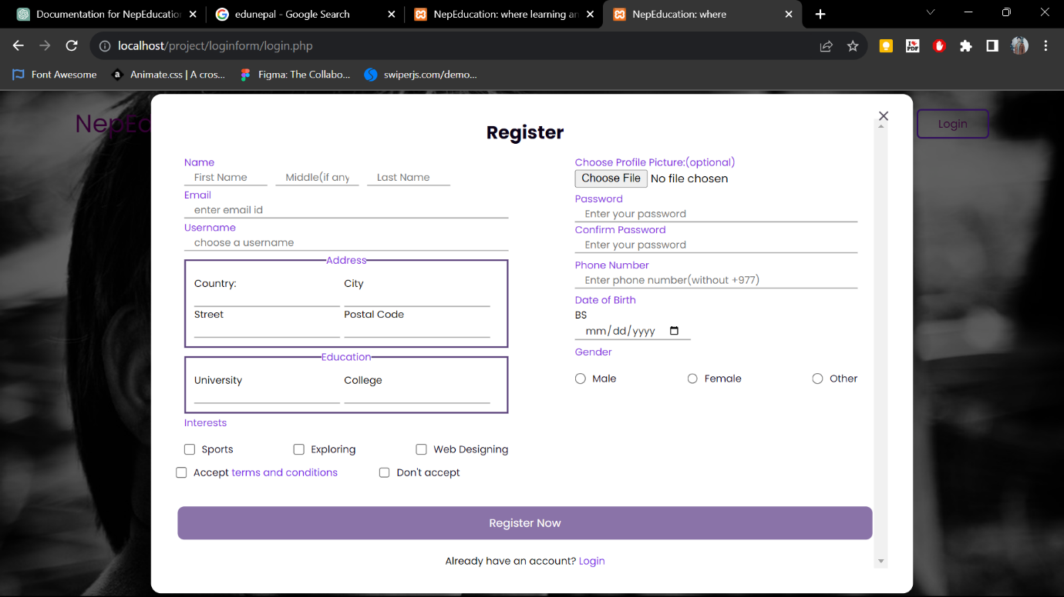

The login and register page also contain the client-side validation like validation in password format, username and error message when the field is left empty.

In the register page the client will not be able to register until accepts the terms and condition which was designed in clint side scripting using JavaScript.

The forms are connected in MySQL that means the registered user details will be stored in database and the login page performs the server-side validation.

The login page will navigate to index.php which is home page only after the username and password matches. Here we have also used session to make the website stateful.

**Homepage:**

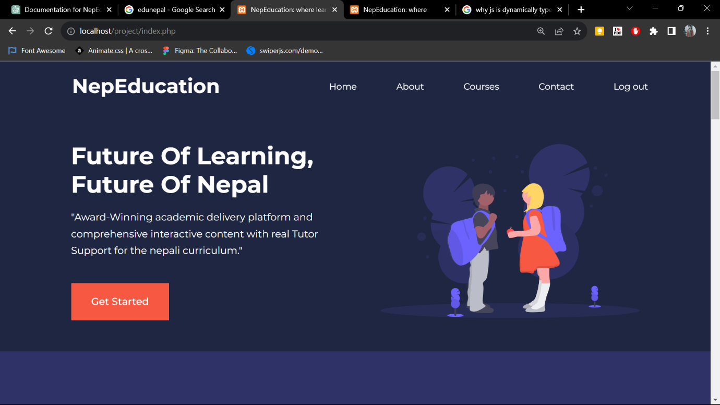The session will be expired when the user logouts. Otherwise not everytime it is necessary to validate by login page.

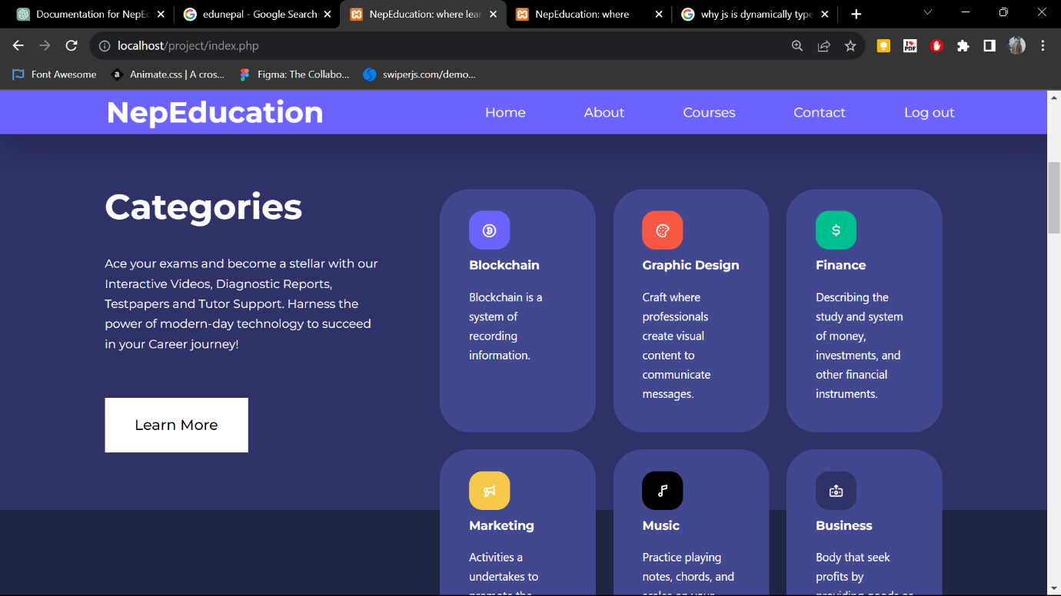**Other Homepage Slides:**

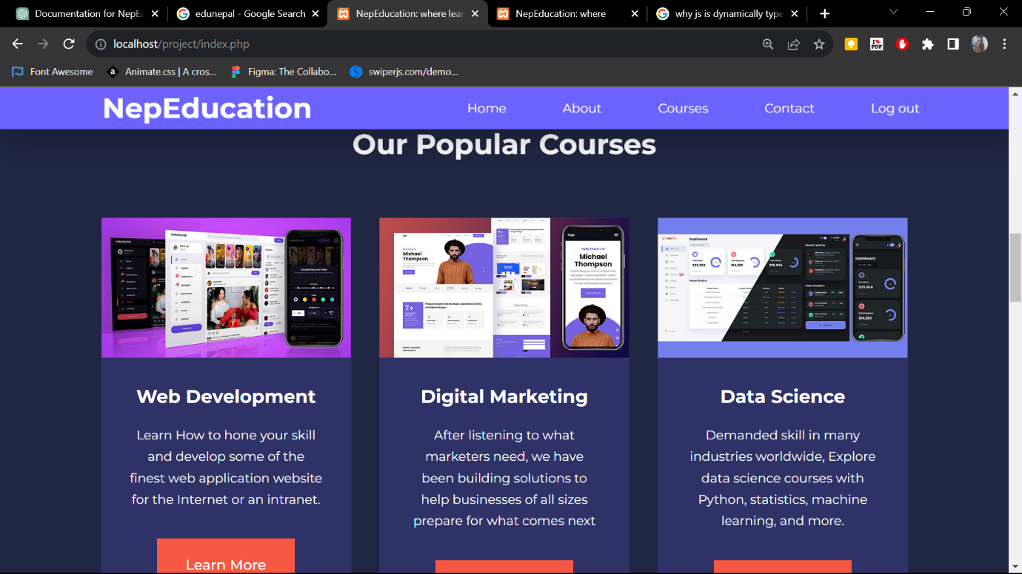

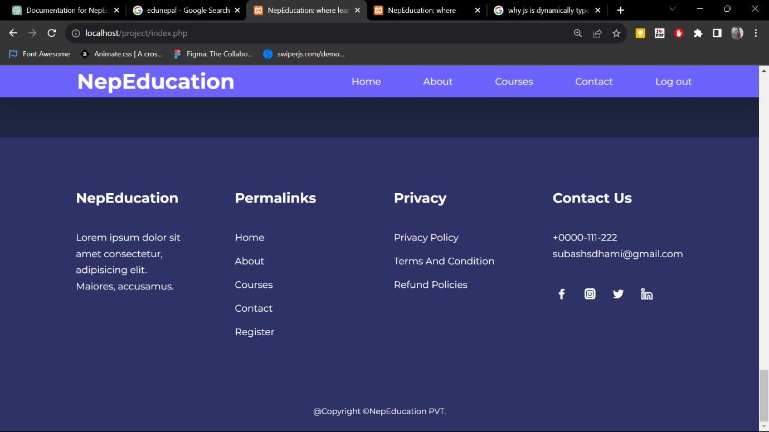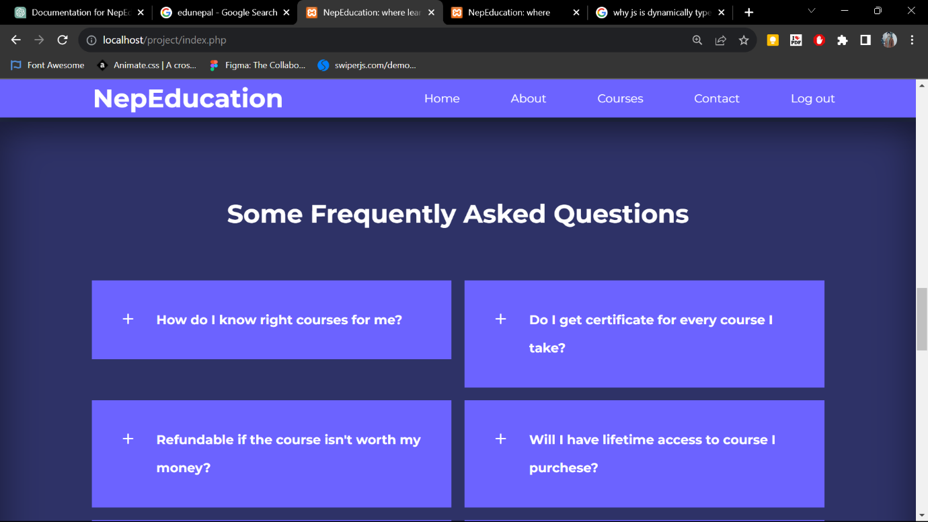

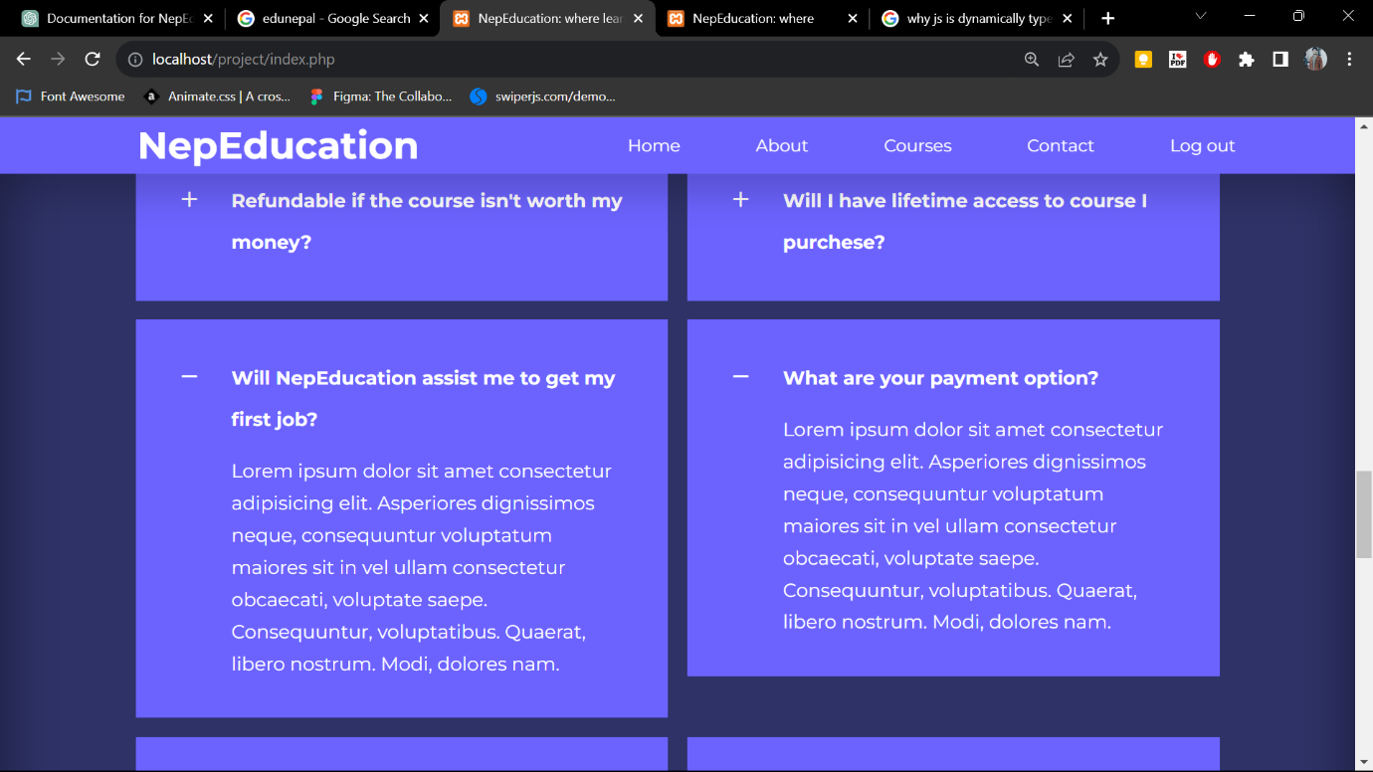

There are navigation buttons in the homepage nav bar which will navigate to different places.

There are header and footer sections. In footer sections there are more details and shortcuts of the page.

On clicking the Log out button in the home page, it will end the session and navigate to login page to inform you that you need to login again.

After log out the if you try to access home page by direct link this will look like:

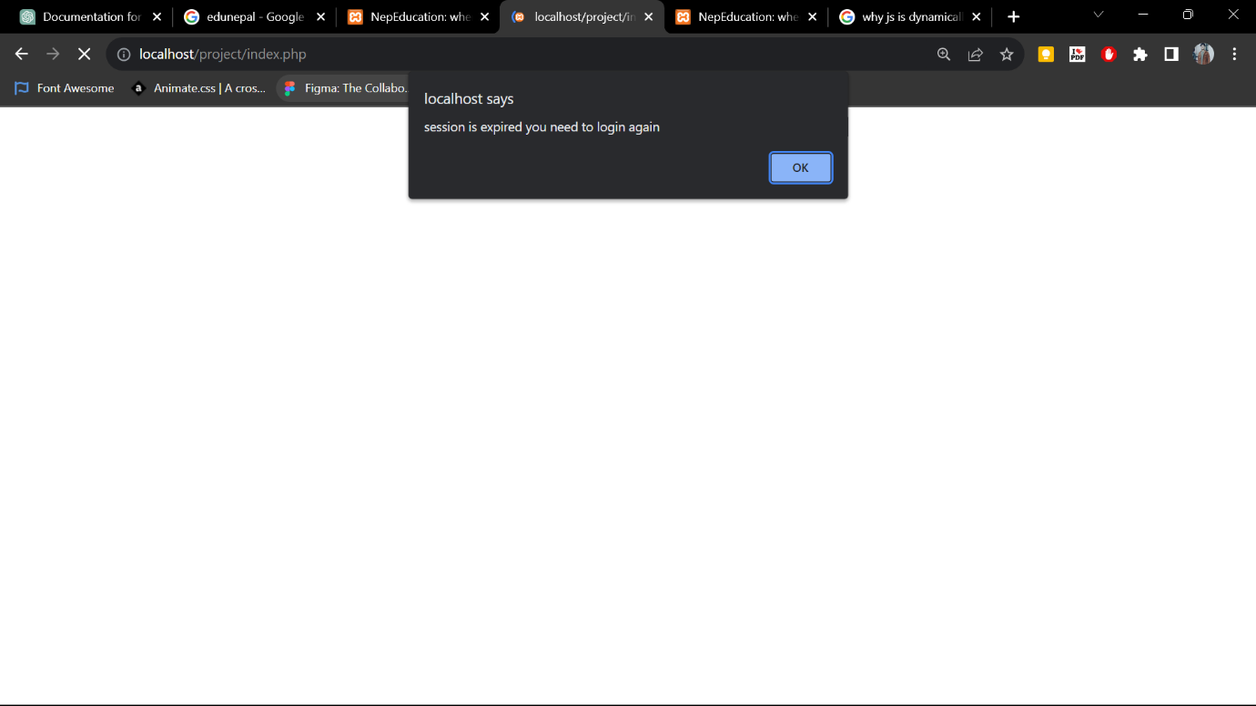

And will navigate to login page by default.

# Future Scope and Enhancement

The development of this project is not merely an accomplishment; it's a stepping stone towards a future of limitless learning possibilities. The project's success paves the way for an array of exciting future enhancements and expansions that will further revolutionize the online education landscape.

1. **Expanded Course Portfolio:**

Enhancement: Continuously augment the course offerings across emerging fields and technologies.

Future Scope: Cater to a broader audience with diverse learning interests, ensuring a comprehensive educational experience.

1. **Adaptive Learning with AI:**

Enhancement: Integrate artificial intelligence algorithms to personalize course recommendations and learning paths.

Future Scope: Tailor learning experiences based on individual preferences, pace, and learning patterns.

1. **Global Learning Community:**

Enhancement: Foster a more robust online community by incorporating virtual study groups and collaborative projects.

Future Scope: Facilitate cross-border interactions and cultural exchange, transcending geographical limitations.

1. **Certification and Skill Validation:**

Enhancement: Implement certification mechanisms to validate acquired skills and enhance employability.

Future Scope: Provide learners with recognized credentials that reflect their proficiency to potential employers.

1. **Advanced Analytics and Insights:**

Enhancement: Develop sophisticated analytics tools to offer learners detailed insights into their progress and performance.

Future Scope: Enable users to track their learning journey comprehensively and make informed decisions.

1. **Interactive Labs and Simulations:**

Enhancement: Incorporate virtual labs and simulations to offer learners hands-on practice in a risk-free environment.

Future Scope: Enhance practical skill development through immersive learning experiences.

1. **Collaborative Project Marketplace:**

Enhancement: Create a platform where learners can collaborate on real-world projects and showcase their teamwork.

Future Scope: Cultivate an ecosystem of innovation and industry-aligned projects for learners to engage with.

The path forward for the NepEducation website is illuminated by innovation, adaptability, and a commitment to addressing the ever-evolving needs of learners. The future scope and enhancements envision a platform that transcends the boundaries of traditional education and paves the way for a new era of empowered, engaged, and future-ready learners.

# Conclusion

In the realm of the "**Development of NepEducation Website,"** our journey has been one of innovation, dedication, and the unwavering belief that education is the cornerstone of progress. As we conclude this project, we stand at the precipice of a new era in learning, where traditional barriers yield to the boundless potential of the digital age.

The voyage of crafting this platform has been driven by a singular purpose: to transcend the limitations of conventional education and open the doors to a world where knowledge is accessible, interactive, and ever-evolving. Through painstaking design, methodical implementation, and constant refinement, we have given rise to a virtual space that not only imparts skills but also ignites curiosity, fosters collaboration, and empowers learners to script their own success stories.

From interactive modules that transform passive learning into an immersive experience to secure transactions that instill confidence, every aspect of the NepEducation website has been engineered to provide an educational voyage that matches the pace of an ever-evolving world. But this is not the culmination; rather, it's a prelude to the limitless possibilities that lie ahead.

As we gaze toward the horizon, we envision a future where our platform expands its horizons, integrating artificial intelligence, fostering global learning communities, and embracing adaptive learning paths that cater to the unique journey of each learner. Our journey is marked by constant evolution, driven by the very spirit of learning that we seek to inspire in others.

In the end, the "**Development of NepEducation Website**" is not just a project; it's a manifesto. It's a commitment to reshaping education, to fostering innovation, and to sculpting minds that will shape the future. Our journey is far from over, and we invite learners, educators, and dreamers from every corner to join us as we pave the path to a future where knowledge knows no bounds and the pursuit of excellence knows no limits.